Directions for In-class Demonstrations

I. Pizza Pan Immunology

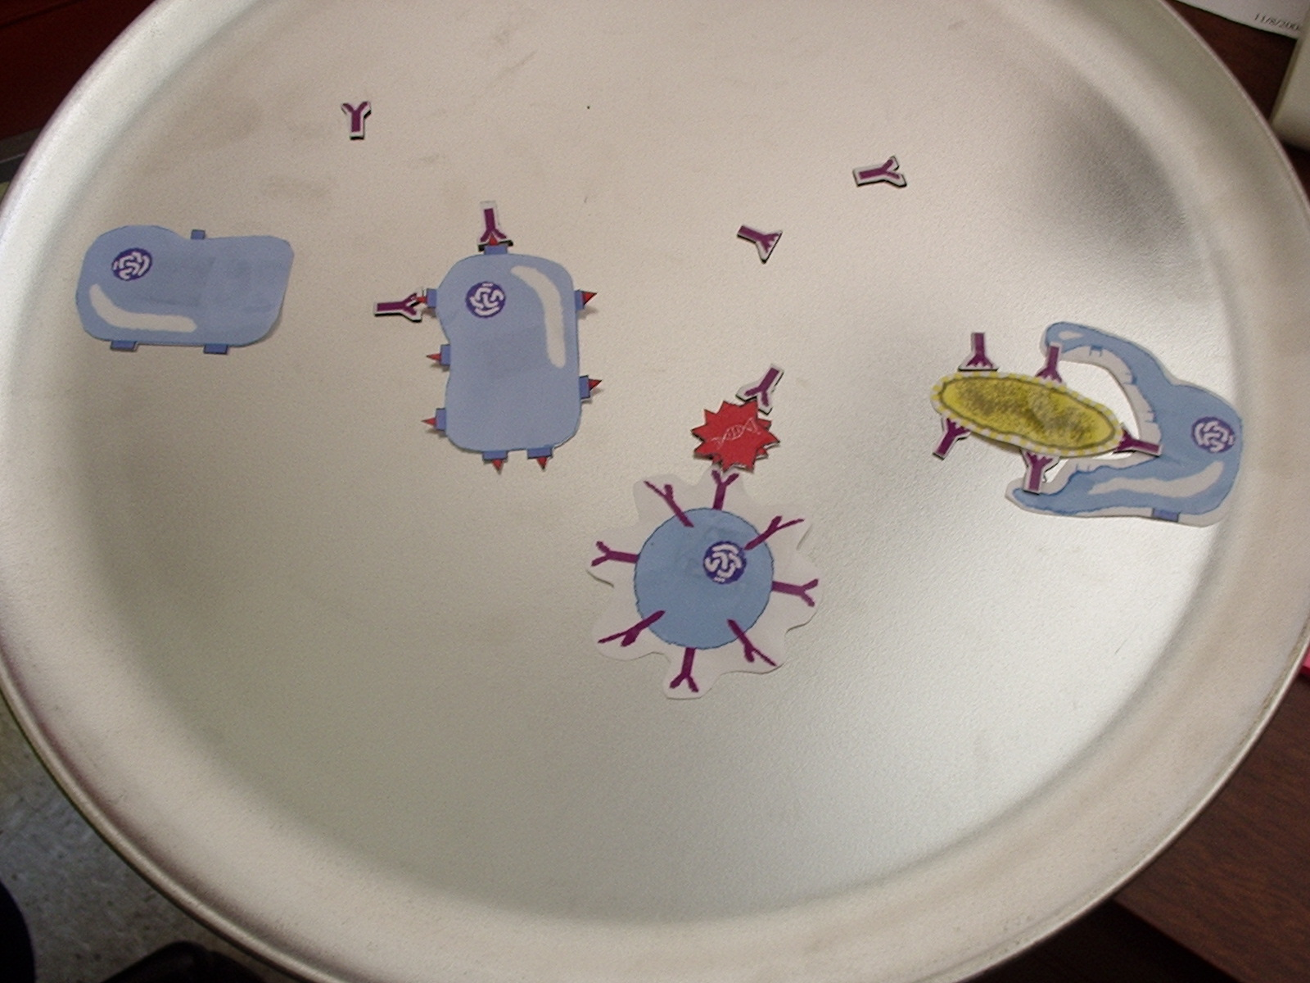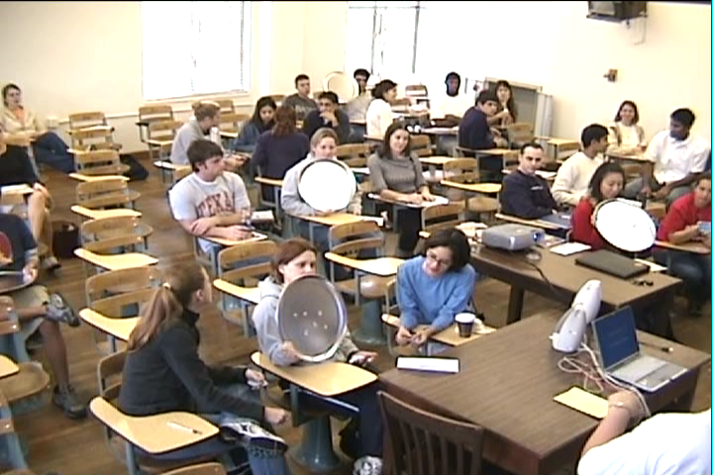

Purpose: This activity makes the process of learning immunology, one of the more complex and daunting lessons of the course, more interactive and clear. It also allows the teacher to address any misconceptions that students may have on the spot.
*Materials: 10, 12” pizza pans
10 sets of magnets
To make magnets: 1. Laminate the page containing the cell cartoons. 2. Cut out cell and antibody shapes. 3. Using business card magnets (peel and stick), paste cut-outs on the magnet. 4. Trim excess magnet to fit the cut-out.
Conducting the activity: 1. Assign students to groups of ~ three. 2. In response to teacher questioning, have students display their answers on the pizza pan with the magnets. Students should then hold up the pizza pans so the teacher can quickly assess the general understanding of the class. 3. Teacher then asks a group to come before the class to explain why they displayed a particular magnet or magnets. 4. Steps two and three are repeated with different questions covering basic immunology principles.
*Quantities listed are for a class size of 30.
II. Town Hall Meeting
Purpose: This activity is designed to illuminate the ethical and logistical complexity of developing a vaccine that requires human subject testing.
Materials: One sign for each member of the council – ten total. The front of each sign should display the council member’s name and title. The back should display actual quotes from each individual that convey their stance on this controversial issue.
Conducting the activity: 1. Have students prepare questions to be asked to the council the day before. 2. Assign one student to play the role of a particular council member. Do this for each council member. The remaining students will make the audience that will be questioning the council. 3. Have ‘council members’ read the quotes on the back of the signs to the class. This will inform everyone on where they stand on the issue. 4. Begin audience questioning. Any member of the council can answer, but they should answer as though they were the individual on the front of their sign. The teacher should encourage debate amongst the council over the question that has been asked. Once the question has been addressed thoroughly, proceed with another question from the audience. The teacher may need to intervene to make sure each member of the council has contributed to the debate.
III. Take Apart Activity
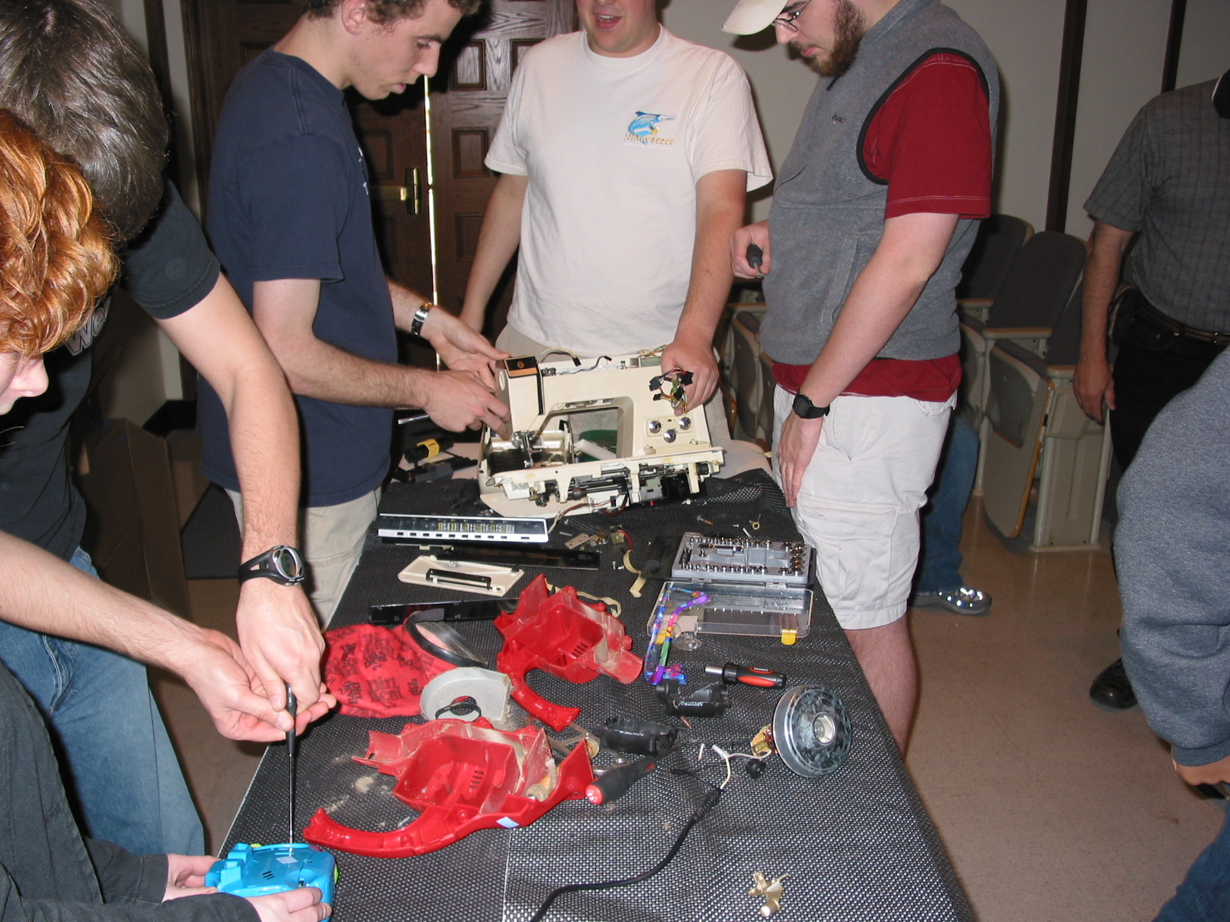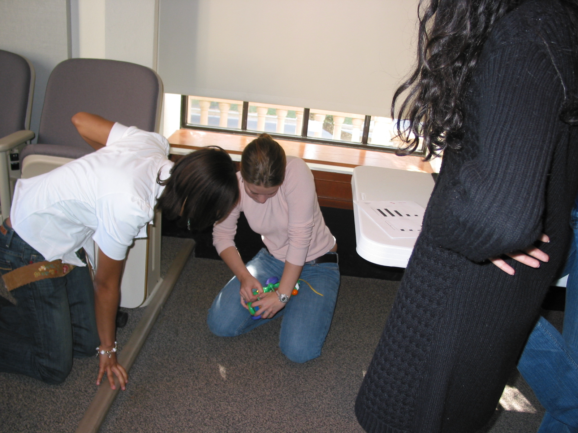
Purpose: This activity is designed to engage students in the engineering process. By taking apart, or reverse engineering, a simple device, students can see why certain components are needed and how those components address certain constraints.
*Materials: 10 simple devices (e.g. toys, tape recorders, water pumps…etc)
10 tool sets (sets should include: hammer, flat head and phillips screw drivers, and an allen wrench)
Enough protective covering to lay atop desk surfaces.
Conducting the Activity: 1. Before beginning the activity, have protective covering laid across the students’ desk tops. 2. Distribute devices so that there are about three students per device. 3. Pass out tool sets. 4. Commence taking apart the devices. 5. At the end of the activity have students bring up and present any interesting findings/components to the class. If there is extra time challenge students to put it back together!
*Quantities are for classes of size 30
IV. Designing a Health Care System
Purpose: This activity demonstrates the difficulty in formulating an effective yet fair health care system and how this problem is exacerbated by a low per capita annual health expenditure.
*Materials: ‘Designing a Health Care System: How will you distribute your resources?’ handouts for each student
32 envelopes: 8 will contain the per capita health expenditure (PCE) for Myanmar, 8 will contain the PCE for Angola, 8 will contain the PCE for Canada, and 8 will contain the PCE for the United States. Each envelope should be labeled with a city within that country and the name of the country on the front.
* Quantities used are for a class size of 30
Conducting the Activity: 1. Evenly distribute envelopes to class. 2. Have students open the envelopes and then guess what the amount inside represents. 3. Have students form groups with their country (there should be about 4 students/group). 4. Students must now select from a list of health care services what services will be covered with the money they have. They must be prepared to justify their distribution of available funds.*
*Ultimately we would like students who represent Least Developed Countries to ask Canada or the U.S if they can borrow some money. It turns out that the U.S. is able to fund every service on the list and still have some money left over. Borrowing of money is what takes place in the real world.
V. Confidential Test Results.
Purpose: This activity challenges students to weigh the potential risks of being screened for a disease, and in this case specifically, ovarian cancer. This lesson demonstrates the danger in using a screening tool with a poor sensitivity/ or specificity.
Materials: 32 envelopes: The envelopes will be divided up into the following groups with the corresponding changes to an exam grade inside each envelope;
(1) Your screening test correctly identified stage I ovarian cancer and it is 100% treatable at this stage = 100% on the exam
(2) Your screening test did not identify stage IV ovarian cancer. It is beyond treatment and you are going to die = -10pts. on the exam.
(3) Your screening test correctly identified that you do not have ovarian cancer = No change to your grade on the exam
(4) Your screening test incorrectly identified that you have ovarian cancer but in reality you do not and you must have an expensive and painful biopsy unnecessarily = -1pt on the exam.
The number of envelopes in each group is determined by class size and stats on ovarian cancer screening (Rates of false positives, and false negatives).
Conducting the Activity: During the lesson on screening for ovarian cancer, students will be given a chance to be screened in a simulation that uses relative rates of false positives but applies it to penalties or bonuses on the next class exam.
1. Pass out sealed envelopes to students at the begging of class. Inform students upon passing out the envelopes to wait to open them and that there will be three separate opportunities given throughout the lecture to choose to be screened(open their envelopes). At the beginning of the lecture there is a slide explaining what is inside each envelope. Students are told that if they choose to open their envelope the will incur the change to their exam grade, for better or for worse.
VI. Chronology of Science
Purpose: To demonstrate….
*Materials: 10 copies of each quote
7 different colors of card stock, 10 sheets of each
Making Cards: 1. Assign a color to each year. 2. Cut out quotes and glue to corresponding color/year. Make 10 sets of color-coded quotes (each set will have seven different colored cards). Make one master set with the year in which the quote was given on the back.
Conducting the Activity: 1. Assign students to groups of three. 2. Give each group a set of quotes. 3. Allow students to arrange quotes in what they think is the correct chronological order. 4. The teacher can easily look at groups of students and determine if they have put them in the correct order. 5. Pick a group or groups to come down and explain why they chose the order they did. 6. Reveal the correct order.
* Quantities are given for a class size of 30.

